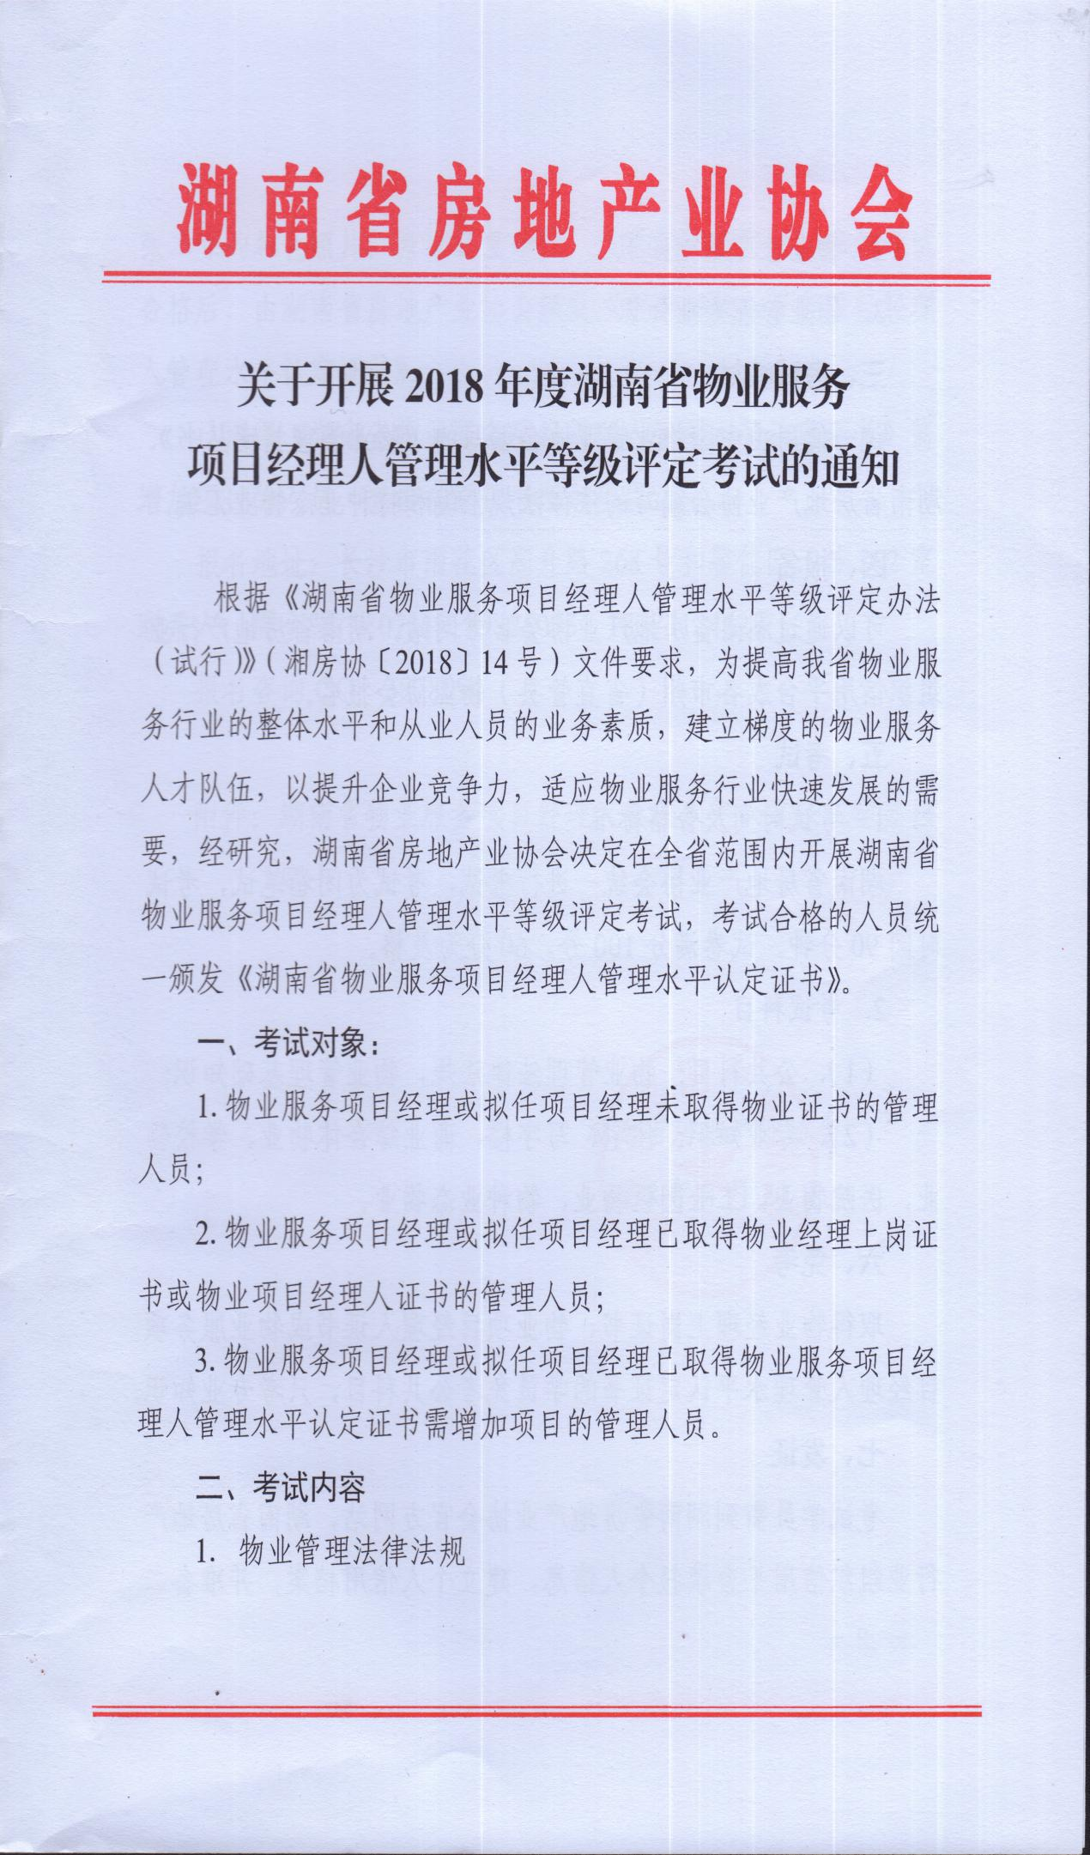

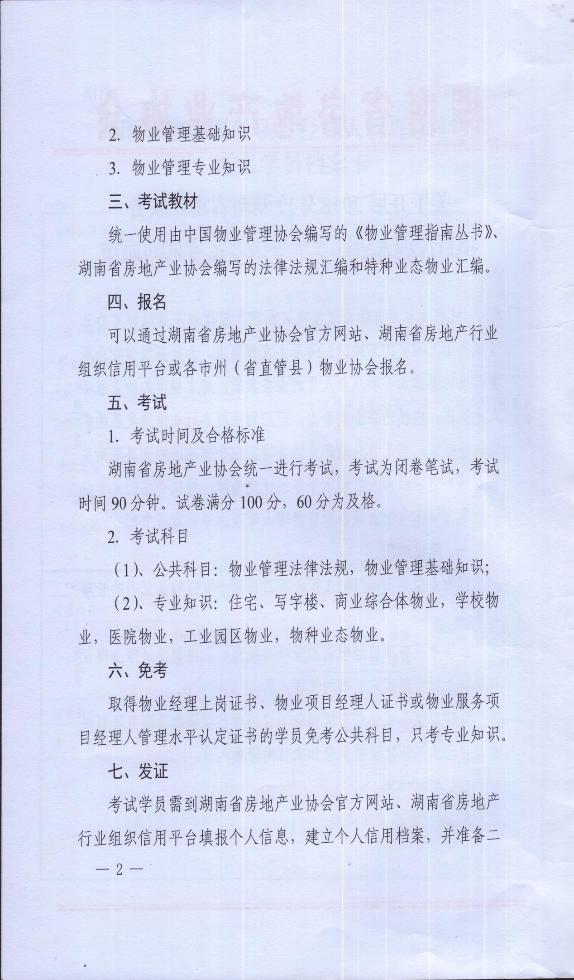

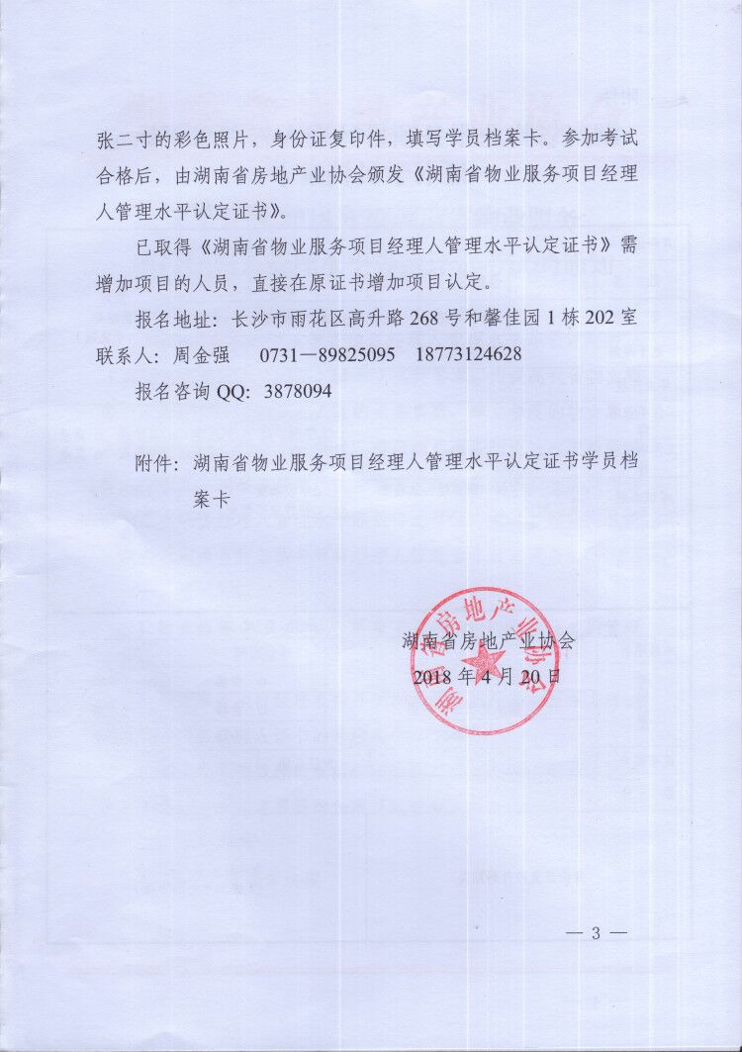

湖南省物业服务项目经理人管理水平认定证书

学员档案卡

**NO:**

湖南省房地产业协会 制

|  |  |  |  |  |  |  |  |  |  |  |  |  |  |  |  |  |  |  |  |  |  |  |  |  |  |  |
| --- | --- | --- | --- | --- | --- | --- | --- | --- | --- | --- | --- | --- | --- | --- | --- | --- | --- | --- | --- | --- | --- | --- | --- | --- | --- | --- |
| 身份证号码 |  |  |  |  |  |  |  |  |  |  | |  | |  | |  | |  |  | |  | |  | |  | 照片  粘贴处  （二寸免冠） |
| 姓 名 |  | | | | 性别 | |  | | 民 族 | | |  | | | | 出生年月 | | | | |  | | | | |
| 职 务 |  | | | | 学 历 | | | | □大专 □本科 □研究生 □其他 | | | | | | | | | | | | | | | | |
| 电子邮箱 |  | | | | | | | | 手 机 | | | | | | | |  | | | | | | | | |
| 毕业院校 |  | | | | | | | | | | | | | | | | | | | | | | | | |
| 工作单位名称 |  | | | | | | | | | | | | | 工作项目类型 | | | | | | | | □ 住宅 □ 写字楼 □ 商业  □ 工业区 □ 医院 □ 其他 | | | | |
| 工作项目名称 |  | | | | | | | | | | | | |
| 考试类别 | □住宅、写字楼、商业综合体物业 □学校物业 □工业园区物业  □医院物业 □特种业态物业 | | | | | | | | | | | | | | | | | | | | | | | | | |
| 工作简历 |  | | | | | | | | | | | | | | | | | | | | | | | | | |
| **以 下 由 湖 南 省 房 地 产 业 协 会 填 写** | | | | | | | | | | | | | | | | | | | | | | | | | | |
| 考核项目 |  | | | | | | | | | | | | | | 考试时间 | | | | | | | | |  | | |
| 考核结果 | 物业管理法律法规 | | | | | | | | | | | | | | □ 合格 □ 不合格 | | | | | | | | | | | |
| 物业管理基础知识 | | | | | | | | | | | | | | □ 合格 □ 不合格 | | | | | | | | | | | |
| 专业知识 | | | | | | | | | | | | | | □ 合格 □ 不合格 | | | | | | | | | | | |
| 证书编号 |  | | | | | | | | | | 发证日期 | | | | | | | | |  | | | | | | |
| 备 注 |  | | | | | | | | | | | | | | | | | | | | | | | | | |
| 身份证复印件粘贴处 | | | | | | | | | | | | | 制作证书照片粘贴处  （1张二寸免冠彩照） | | | | | | | | | | | | | |